NAME: _______________________________ CLASS: _____________

Extended Experimental Investigation

Investigating HEAT Conductance
TASK: To investigate the relationship between the type of material and its ability to conduct heat.
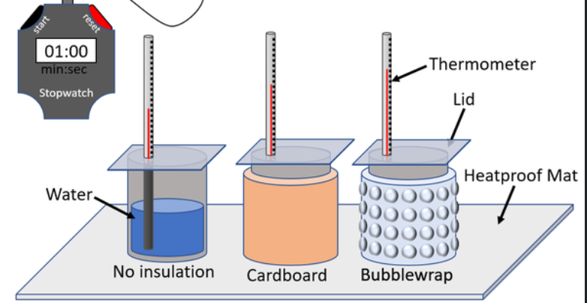
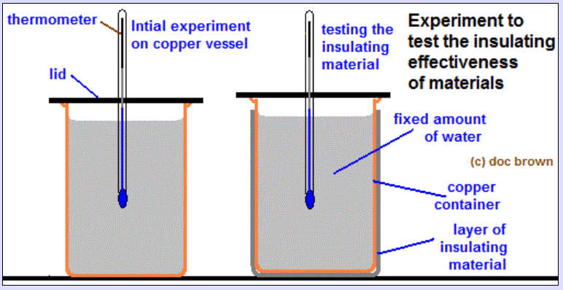

Aim

Hypothesis
(a testable prediction with explanation). What (and why) do you expect to happen?
Materials
(Bulleted list of equipment. Use a double column format)

Risk assessment  What are the possible hazards and how will you manage them? | Source of risk Potential risk Degree of risk Safety precautions
Method
What were the steps in the investigation?
List these in numbered steps.

Represent apparatus with a diagram

Results and observations  Put a heading for your table  Do three trials each time you vary the independent variable  Record measurements in a table.  Draw a graph of Temperature versus time for each material.  Choose the “best” (most representative) trial to graph for each material.  There will be four or five lines (one for each of the materials you investigated.  You will need a key explaining which line is for which material.  Draw a trend line for each set of dots (don’t simple join the dots together0  Draw a bar graph of rate of temperature change for each material.  This uses column 11 and column 1 from your table.  A bar graph is simply a picture of your results so it is not very useful to scientists, and therefore not used very often in Physics or Chemistry. However a bar graph does show your results very clearly and is often used in Biology where there can be a vast amount of data.. | If you do three trials for each variation in your dependant variable, record temperature and times in your notebook and only put the averages in Table 1  Table 1: ___________________________________________  Type of Material Trial Temperature (ºC) Average Temp (ºC) Rate of Temp change (ºC/min)  0 min 2 min 4 min 6 min 8min 10min Temp  1  2  3  1  2  3  1  2  3  1  2  3  1  2  3  Graph 1: Temperature versus time for each material  KEY:  Graph 2: Rate of temperature change for each material  KEY:
Analysis of results  What can you decide or conclude from you results? How does the data support this?  Write a paragraph on each conclusion you make. Use a conclusion as your topic sentence for each paragraph, elaborate or explain it if necessary, then provide the evidence in the form of data from your results.  Identify any errors which are apparent in your results AND explain why you think this.  There are two ways to judge errors and you should use both to identify any possible error.  Firstly- Do the points on your first graph make a consistent trend (are the points close to the trend line or a little “scattered”?).The closer the points to the trend line the less likely error occurred.  Secondly – Is your answer correct? If you have some final value or equation (model), you can make a judgement as to whether it is correct. Compare it with the expected result or your common sense? If it is not correct you have error? | _____________________________________________________________________  _____________________________________________________________________  _____________________________________________________________________  _____________________________________________________________________  _____________________________________________________________________  _____________________________________________________________________  _____________________________________________________________________  _____________________________________________________________________  _____________________________________________________________________  _____________________________________________________________________  _____________________________________________________________________  _____________________________________________________________________  _____________________________________________________________________  _____________________________________________________________________  _____________________________________________________________________  _____________________________________________________________________  _____________________________________________________________________  _____________________________________________________________________  _____________________________________________________________________  _____________________________________________________________________  _____________________________________________________________________  _____________________________________________________________________  _____________________________________________________________________  _____________________________________________________________________  _____________________________________________________________________  _____________________________________________________________________  _____________________________________________________________________  _____________________________________________________________________
Conclusion  State your conclusion(s) and the implication of them (elaborate on each conclusion with a couple of extra sentences). For example, explain why some materials cause a lower rate of heat loss than other materials.  There may be 1 main conclusion or several.  State the degree of error in your conclusion(s) and provide reasons the error has occurred. Provide suggestions to improve the experimental design so these errors could be avoided. Is there so much error that your conclusions are not valid?  Sum up your conclusion by stating if your main conclusion agreed with your hypothesis, and if your conclusions are valid or not. | _____________________________________________________________________  _____________________________________________________________________  _____________________________________________________________________  _____________________________________________________________________  _____________________________________________________________________  _____________________________________________________________________  _____________________________________________________________________  _____________________________________________________________________  _____________________________________________________________________  _____________________________________________________________________  _____________________________________________________________________  _____________________________________________________________________  _____________________________________________________________________  _____________________________________________________________________  _____________________________________________________________________  _____________________________________________________________________

